**Java Full Stack Development**

**Skilling-7**

**ID NO: 190030677 Name: K. Sravani**

**HQL**

**Student.java**

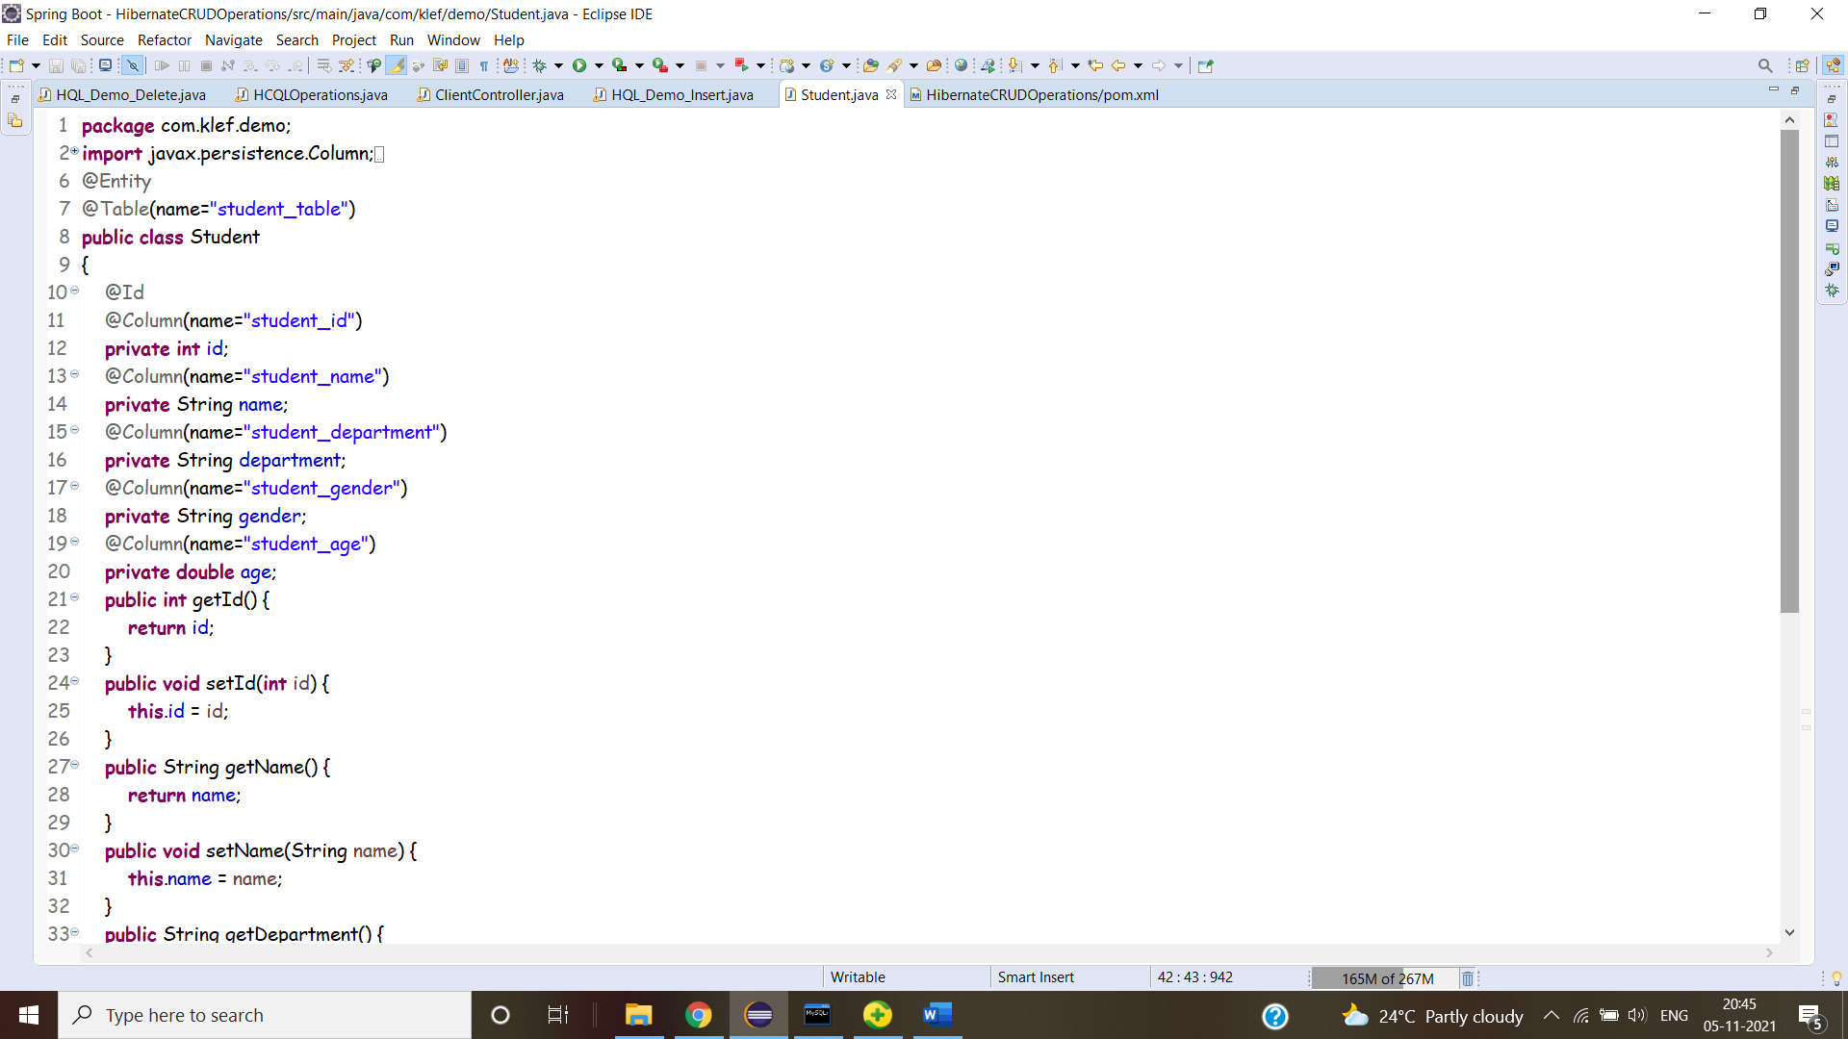

**Hibernate.cfg.xml**

**Insert Operation:**

**Update Operation**

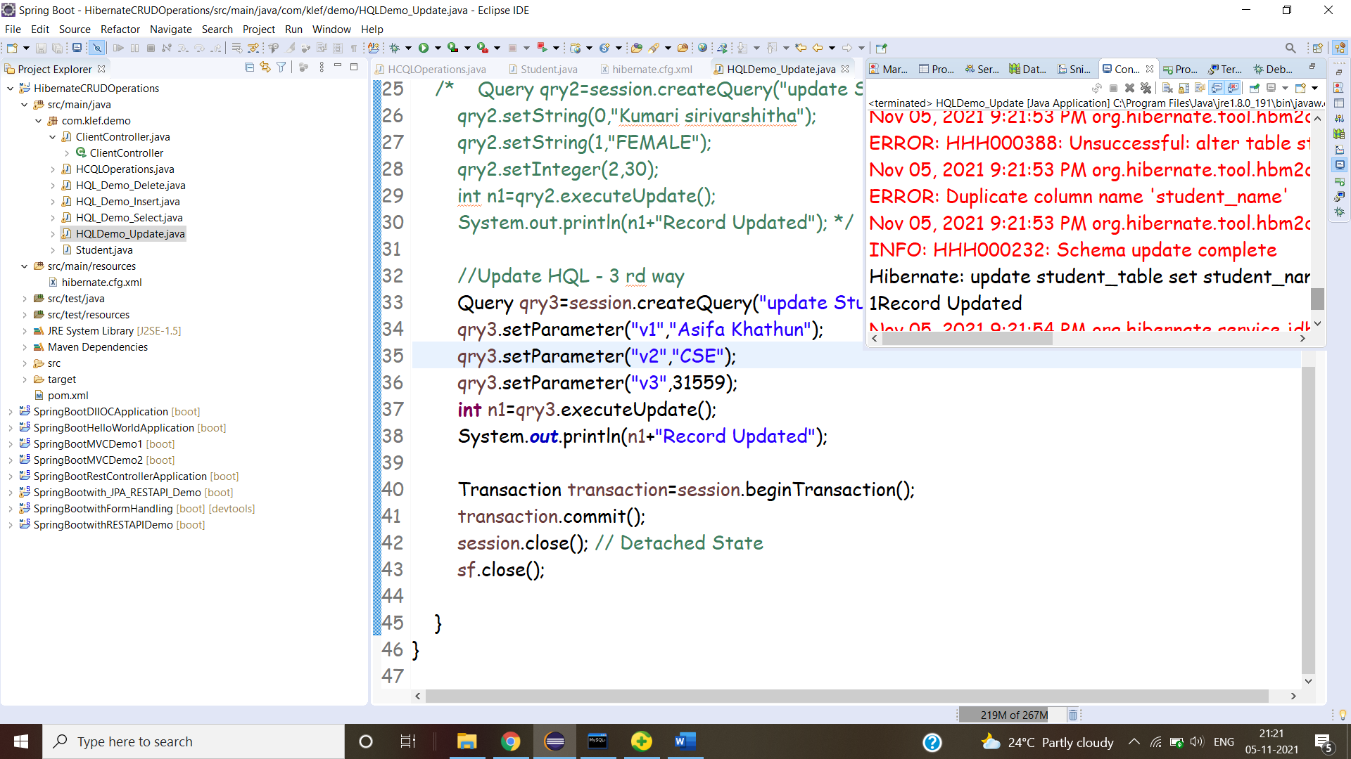

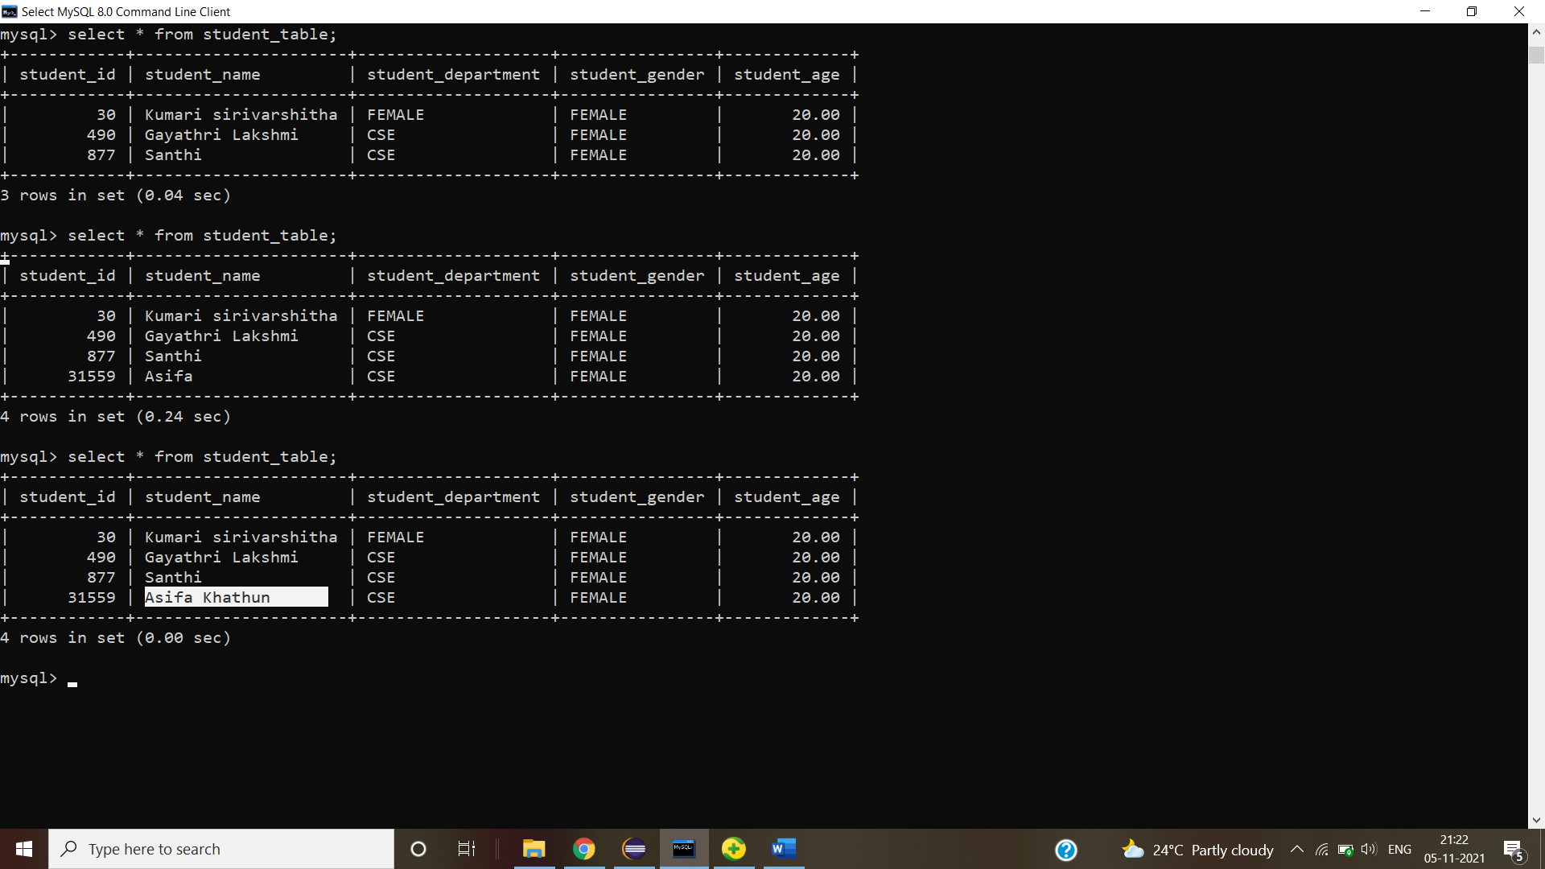

**Delete Operation**

**View Operation**

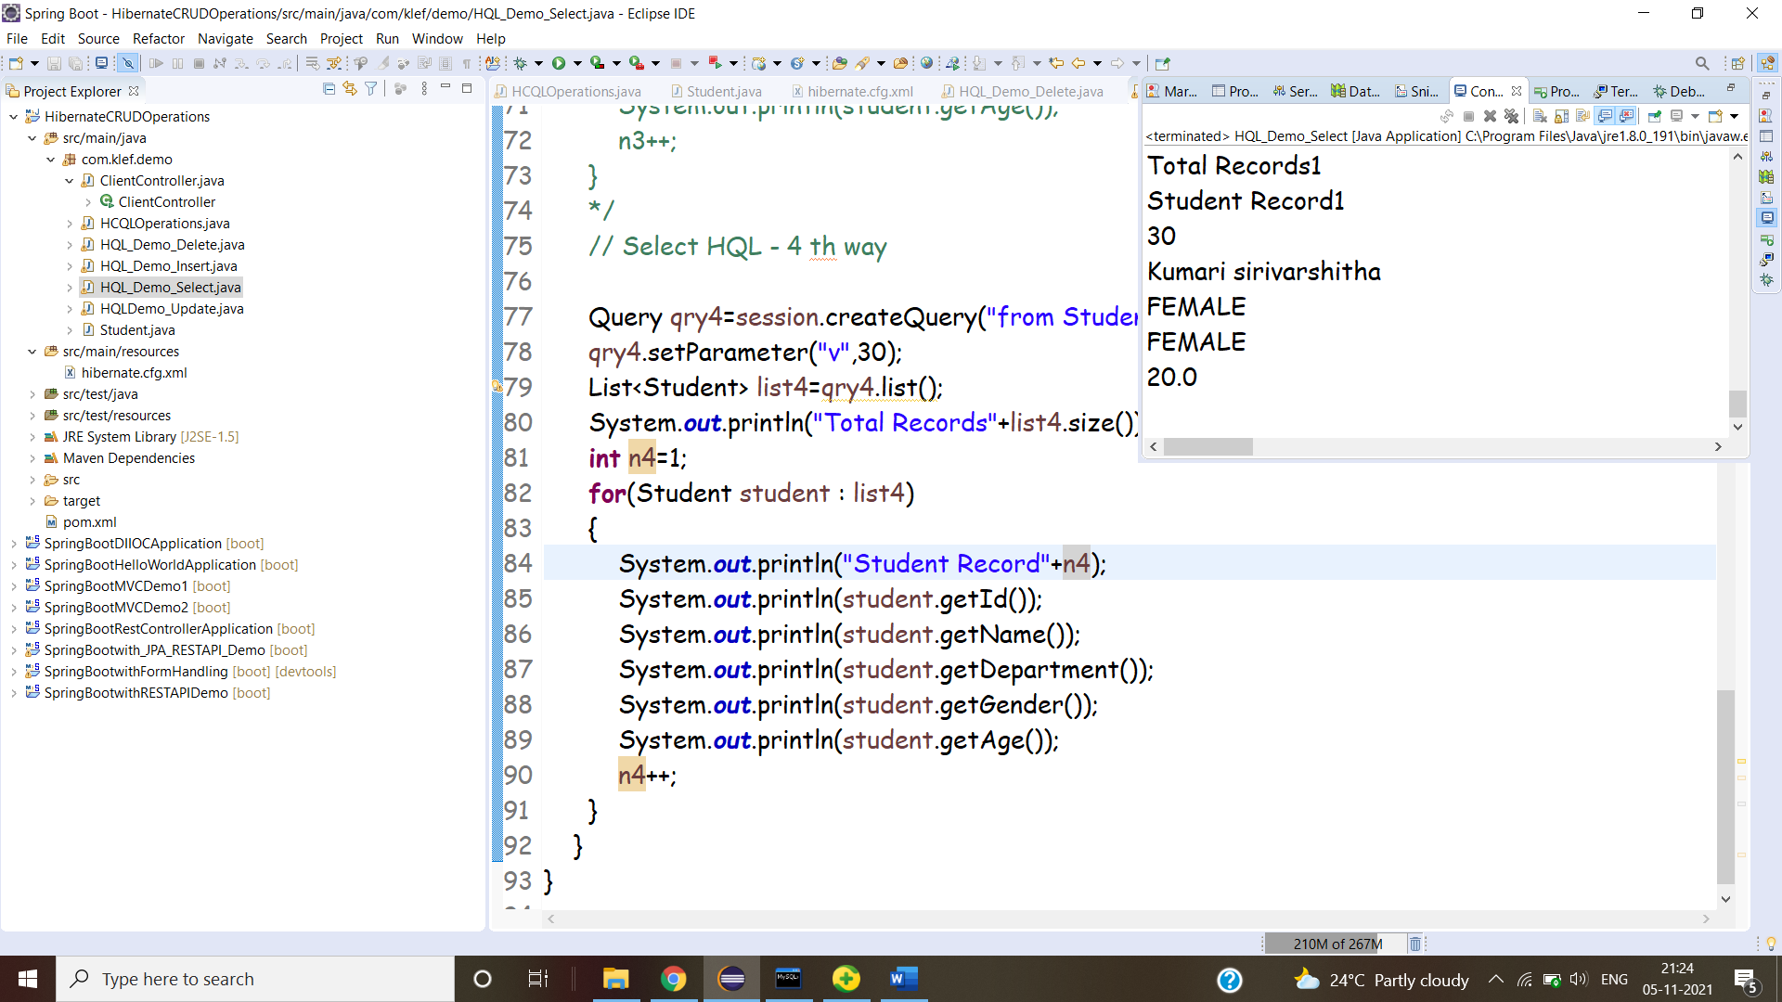

**HCQL**

